Arduino

This file contains a step by step learning method in Arduino. Starting from the most basic LED tasks to eventually controlling a peltier based on temperature.

Arduino has a built in Led at 13. The most basic programming that you can write is to run that led light. With the following code. Delays are variable which will determine the length and the pause between the blinks.

**Adurino Built in LED**

Adurino has a built in LED at 13 which can be contorlled with a simple code.

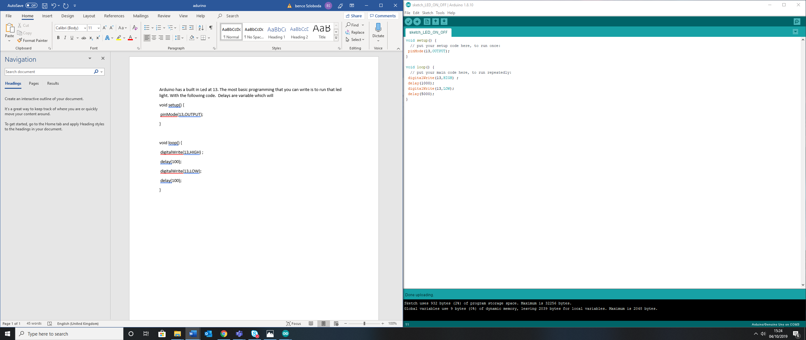

**Adding external LED**

Adding external LED(s) is possible by using a breadboard

LED has a short and a long pin, the short pin is connected to the ground. A resistor is important to be connected in series with a LED as its decreases the current so the LED will not burn out.

The Code will remain the same, however the pin reference must be changed accordingly to where the LED is connected.

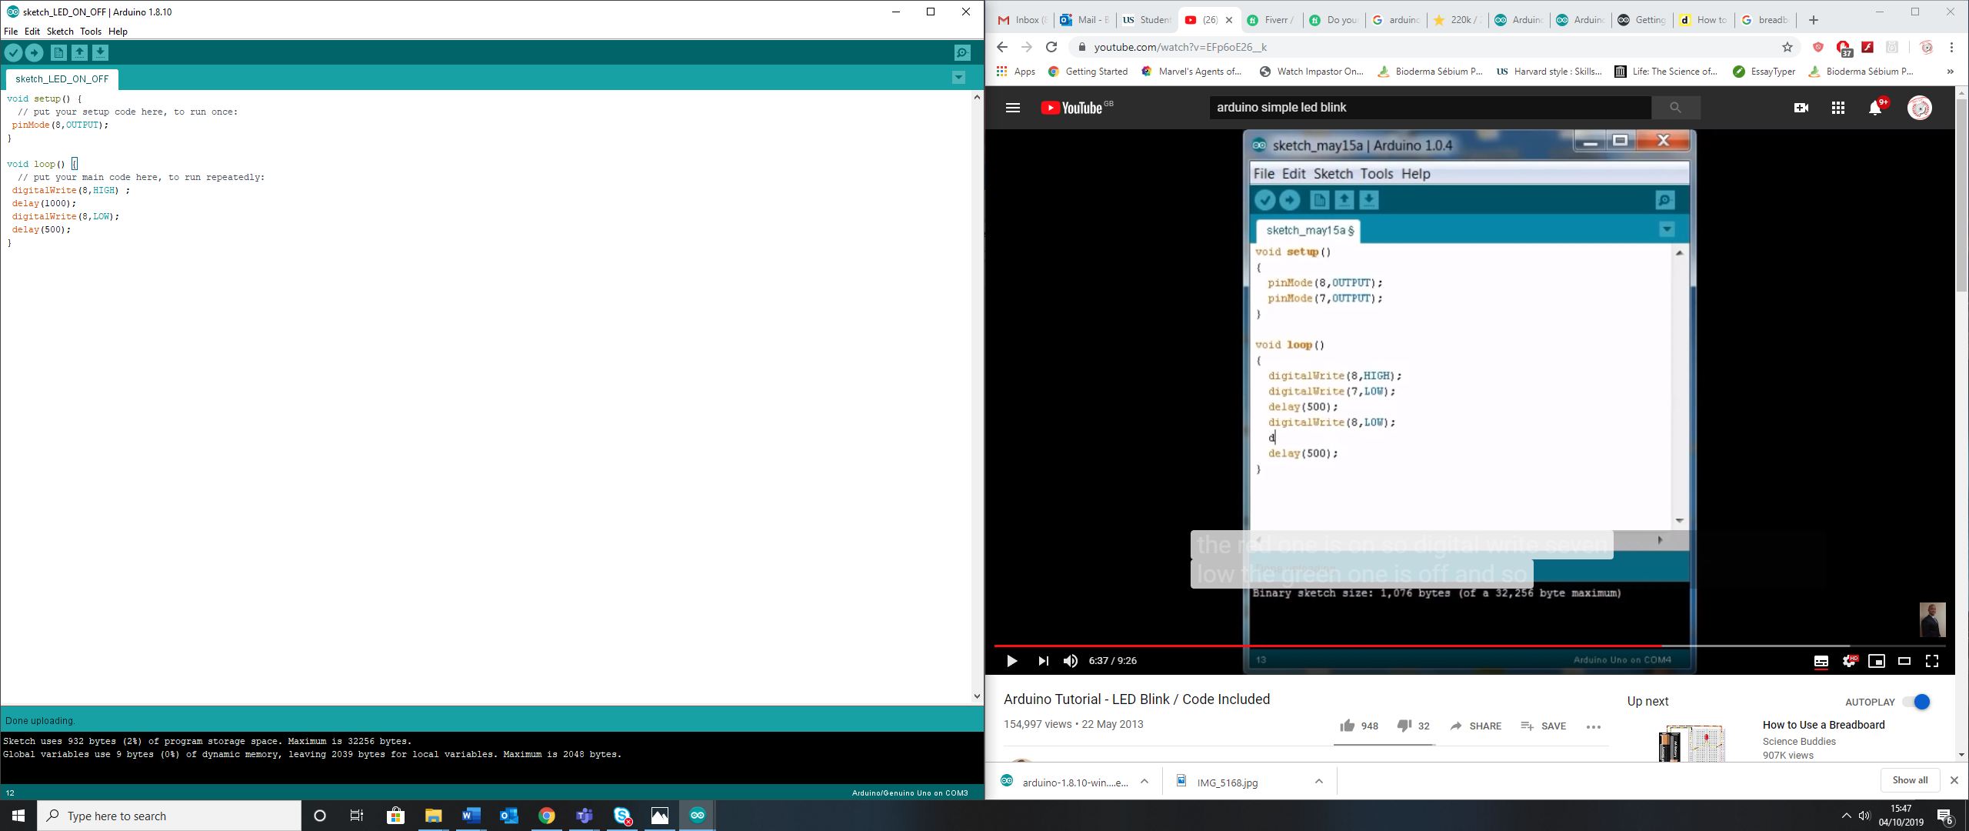

PICS

**Adding a second LED**

New pin needs to be initialized and added to the code. The following code will produce a blinking sequence between the two LEDs. The two LEDs blinking sequence can be manipulated to your liking.

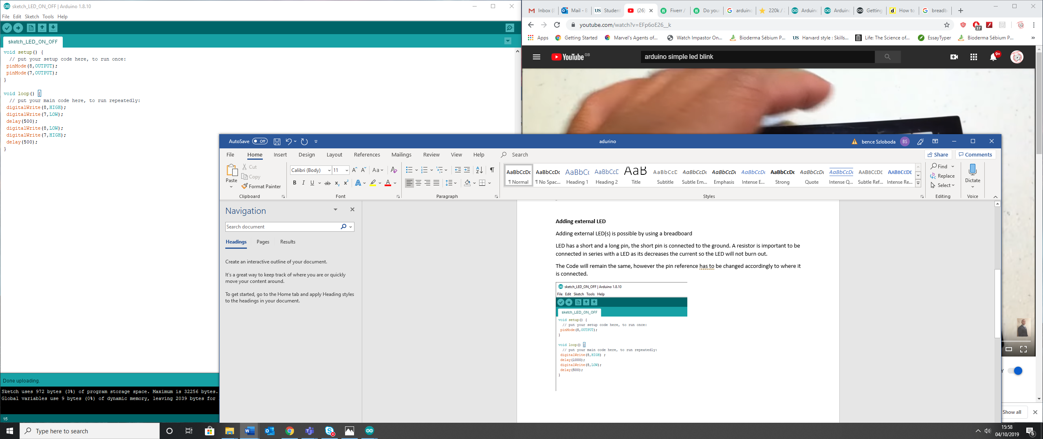

Pics

**Adding Button**

Adding a Button will give you the possibility to turn on and off the connected LED(s) with an external component. ELABORATE how button works

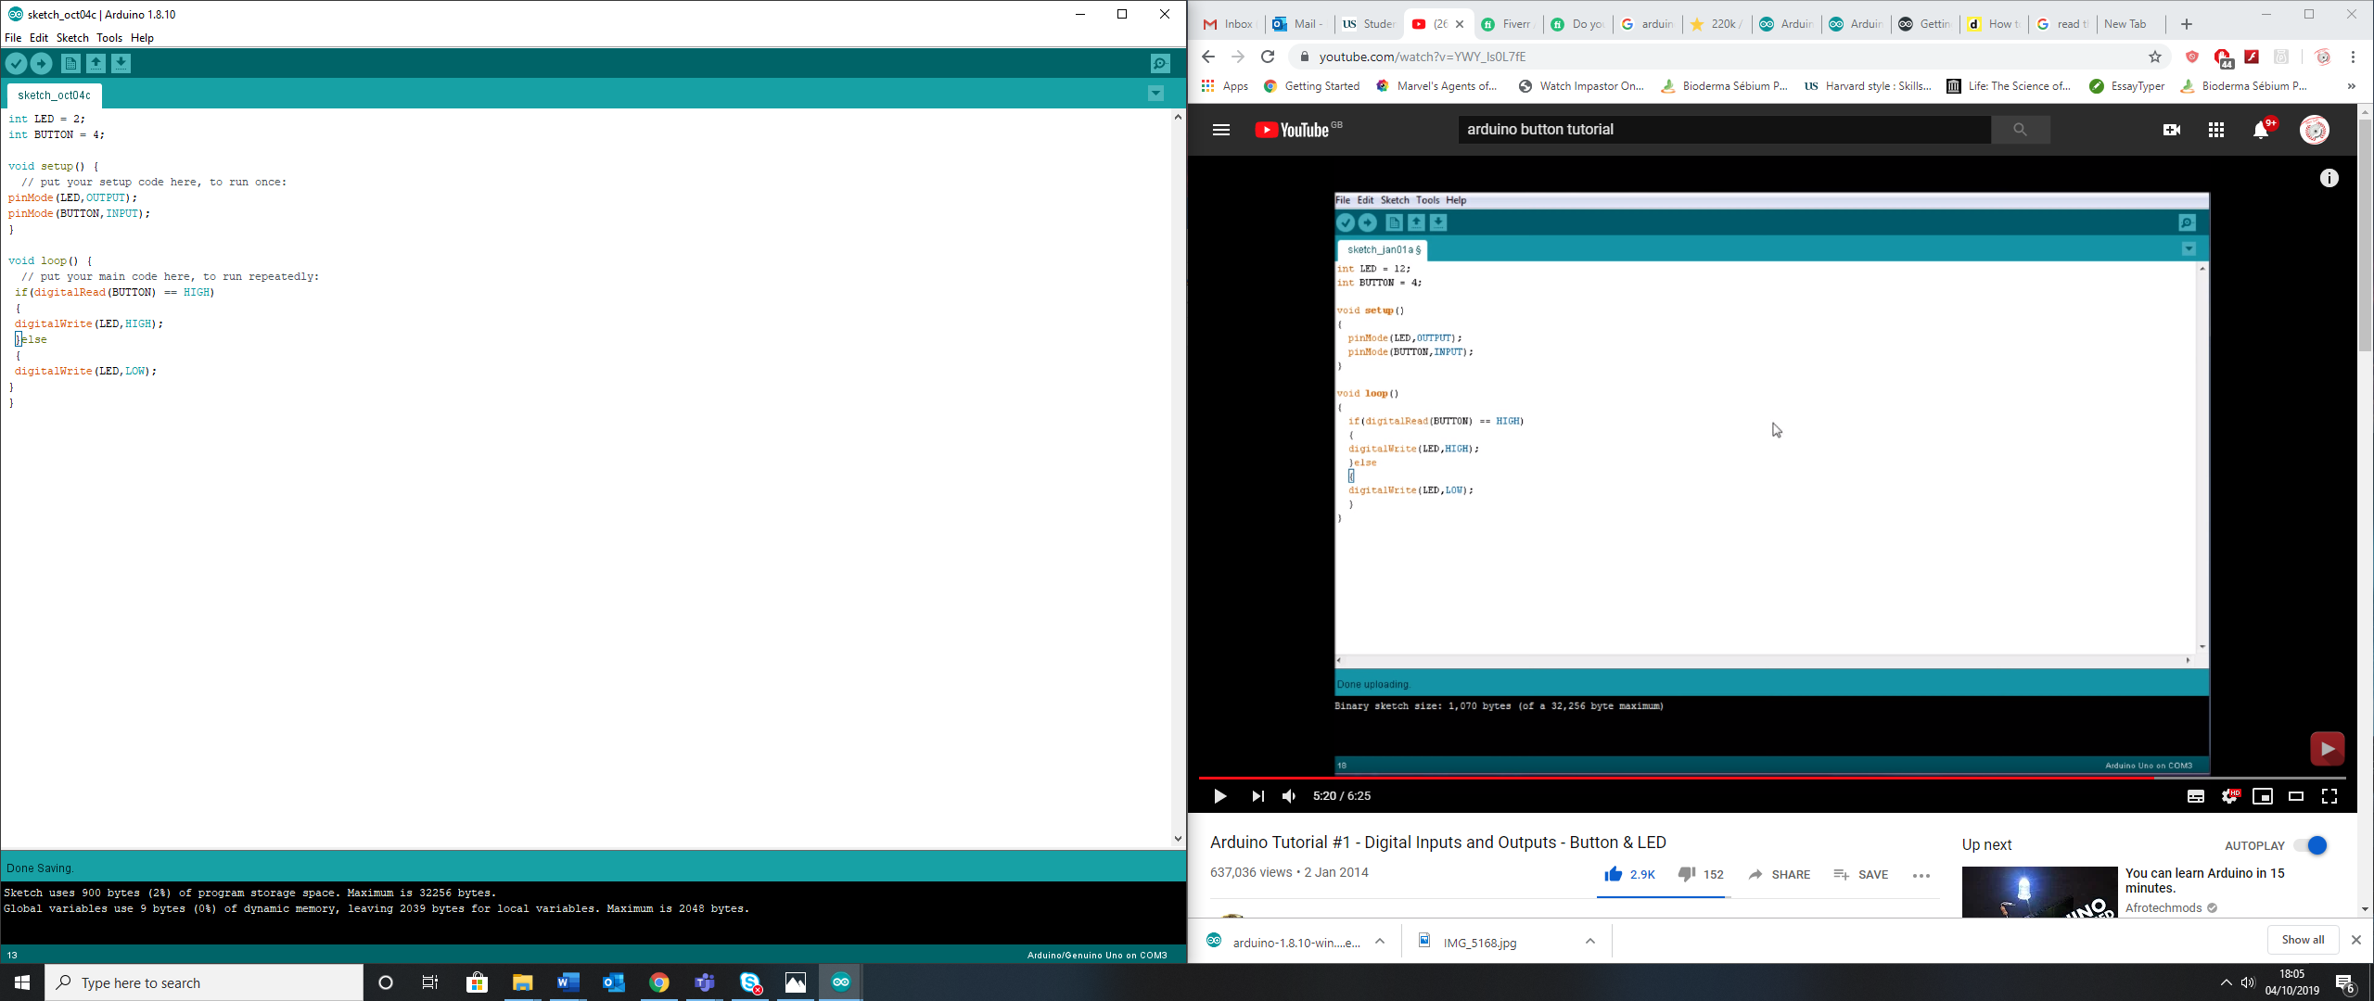

PICS

**Getting Serial Readings**

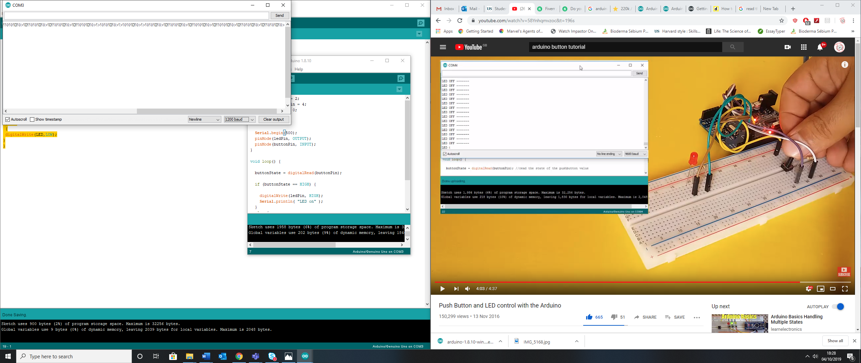

As I was getting Serial readings

When I changed to Serial.begin(9600) it was working

Having completed these tasks my next aim will be to learn about the potentiometer and variable resistance

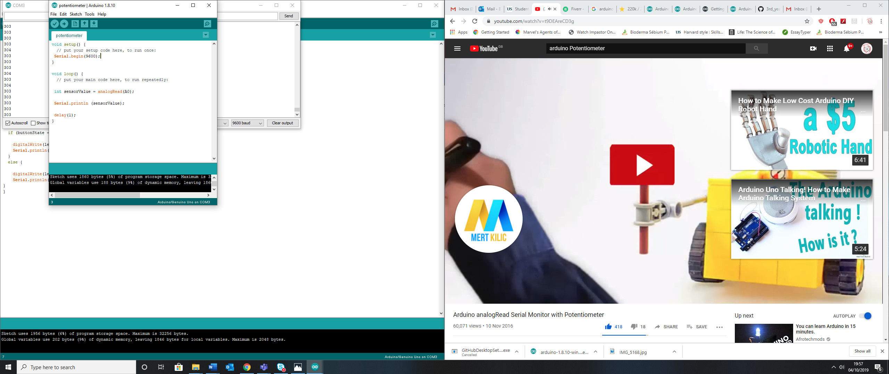

**Using Potentiometer to control LED brightness**

You can control the brightness of a LED by using a potentiometer. The potentiometer has three pins, the outer two are either Ground or 5V and the middle pin is the data pin. The outer pins need to be connected to positive and negative

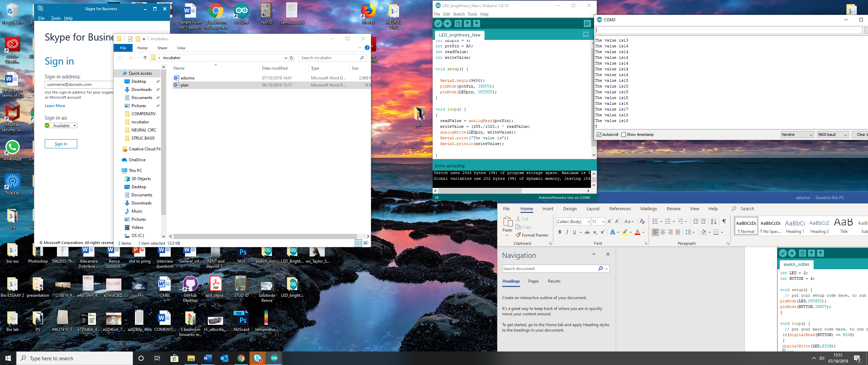

**Using Potentiometer to control LED brightness and increasing blink rate with brightness**